# **README**

## **About the Project/Project Title**

Project Title: Grazioso Salvare Potential Dog Rescue-Training Candidates

This project aims to develop a custom software application for Grazioso Salvare, an international rescue-animal training company. The goal of this project is to build a full-stack application that processes data from local animal shelters near the Austin, Texas area. The software will allow users to view and filter dogs based on animal type which is more suitable for search-and-rescue training. The users will filter the dogs based on features including age and breed. By implementing CRUD functionality in the application, users can manage shelter data effectively. The application will consist of a database backend and a user-friendly web-based dashboard to allow effective navigation.

**Motivation**

This project was created to allow access to the Grazioso Salvare application. This application will allow users to access data view and edit data for potential animal candidates for rescue training. The application will allow users to update and delete data within the rescue database. The application facilitates looking for candidates for the program. Maintaining the application is vital for the function and effectiveness that users are exposed to, hence updating information to accurately represent candidates is vital, and deletion is necessary to avoid unneeded clutter and increase searching efficiency.

## **Getting Started**

To get a local copy up and running the following steps must be executed:

* Install MongoDB
* Upload aac_shelter_outcomes.csv to MongoDB
* Install Python and libraries
* Set up Python CRUD Module as Shelter.py
* Use Jupyter Notebook for Testing
* Open Project 2 ipynb
* Import AnimalShelter class from Shelter.py
* Add images to assets folders

## **Installation**

* Install MongoDB: This can be done at <https://www.mongodb.com/docs/manual/installation/> and choosing the correct platform
* Python: Environment will be needed to run the application, I use Visual Studio Code, which can be downloaded by searching <https://code.visualstudio.com/> on a search engine
* Python Libraries: Since I used Visual Studio Code, I downloaded the Python Extension Pack and ensure pip is included
* Jupyter Notebook: I used this for testing the functionality of the create and read functions in the Python Module, you can install Jupyter using “pip install notebook” in the command prompt
* MongoDB Import: Download the file aac_shelter_outcomes.csv and import using mongoDB
* Import AnimalShelter from Shelter.py once ProjectTwoDashboard.ipynb is open
* Create assets folder in the Project folder
* Load Logo pictures and unique identifier into assets folder

## **Usage**

### **Code Example**

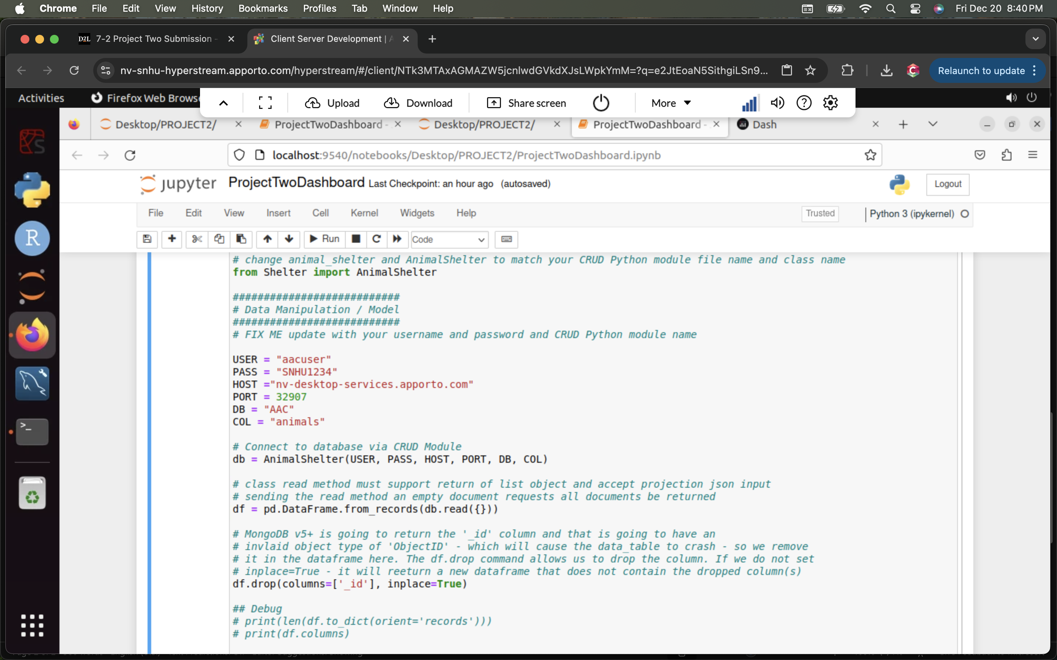

This bit of code we import the AnimalShelter class from the Shelter.py

We hardcode the username, password, host, port, database, and collections. And connect to the database via the CRUD Module.

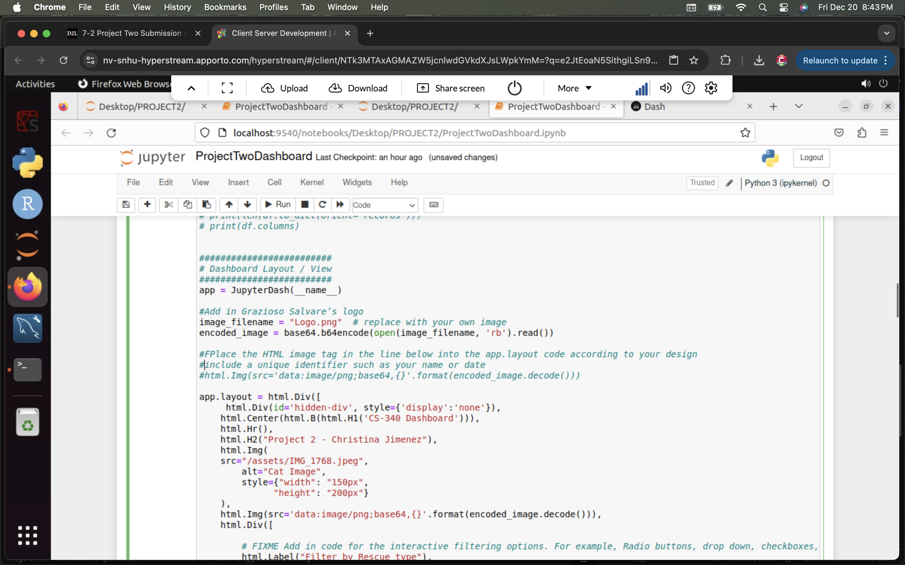This piece of code we add Grazioso Salvare’s logo by opening the file and encoding the image, I also add my unique identifier, a picture of my cat, and also my name.

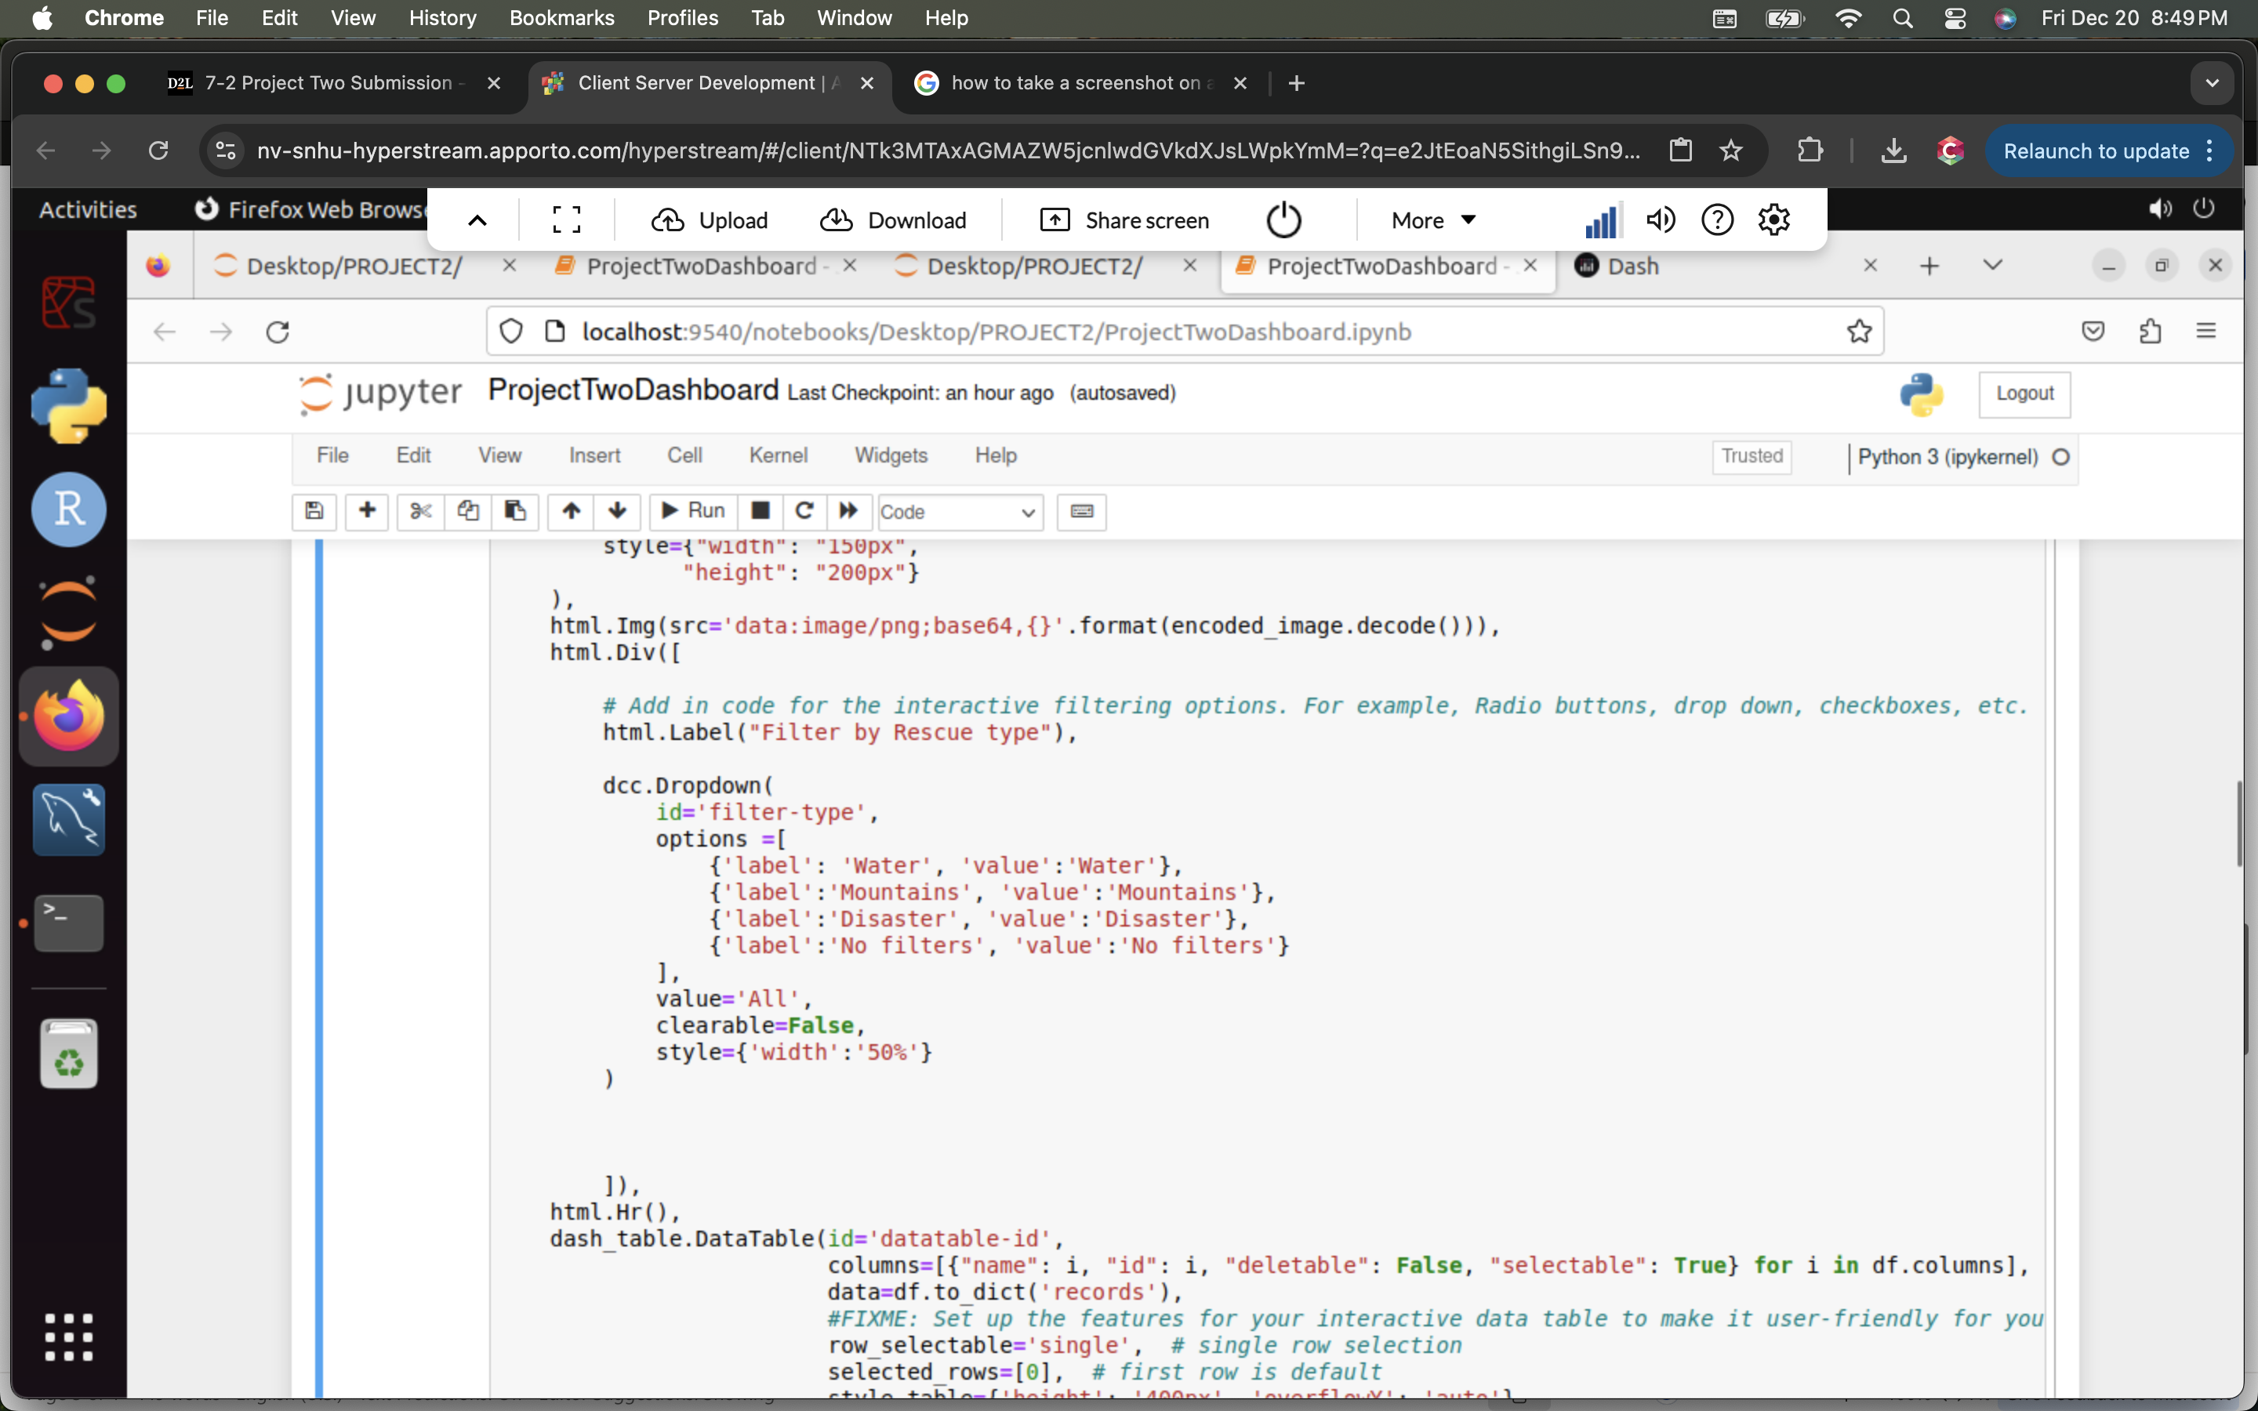This line of code adds a drop-down menu with the following options: "Water”,” Mountains”, “Disaster”, “No filters”, “No filters”, “No filters,” “No filters”, which will allow the user to select the option and will filter the data accordingly.

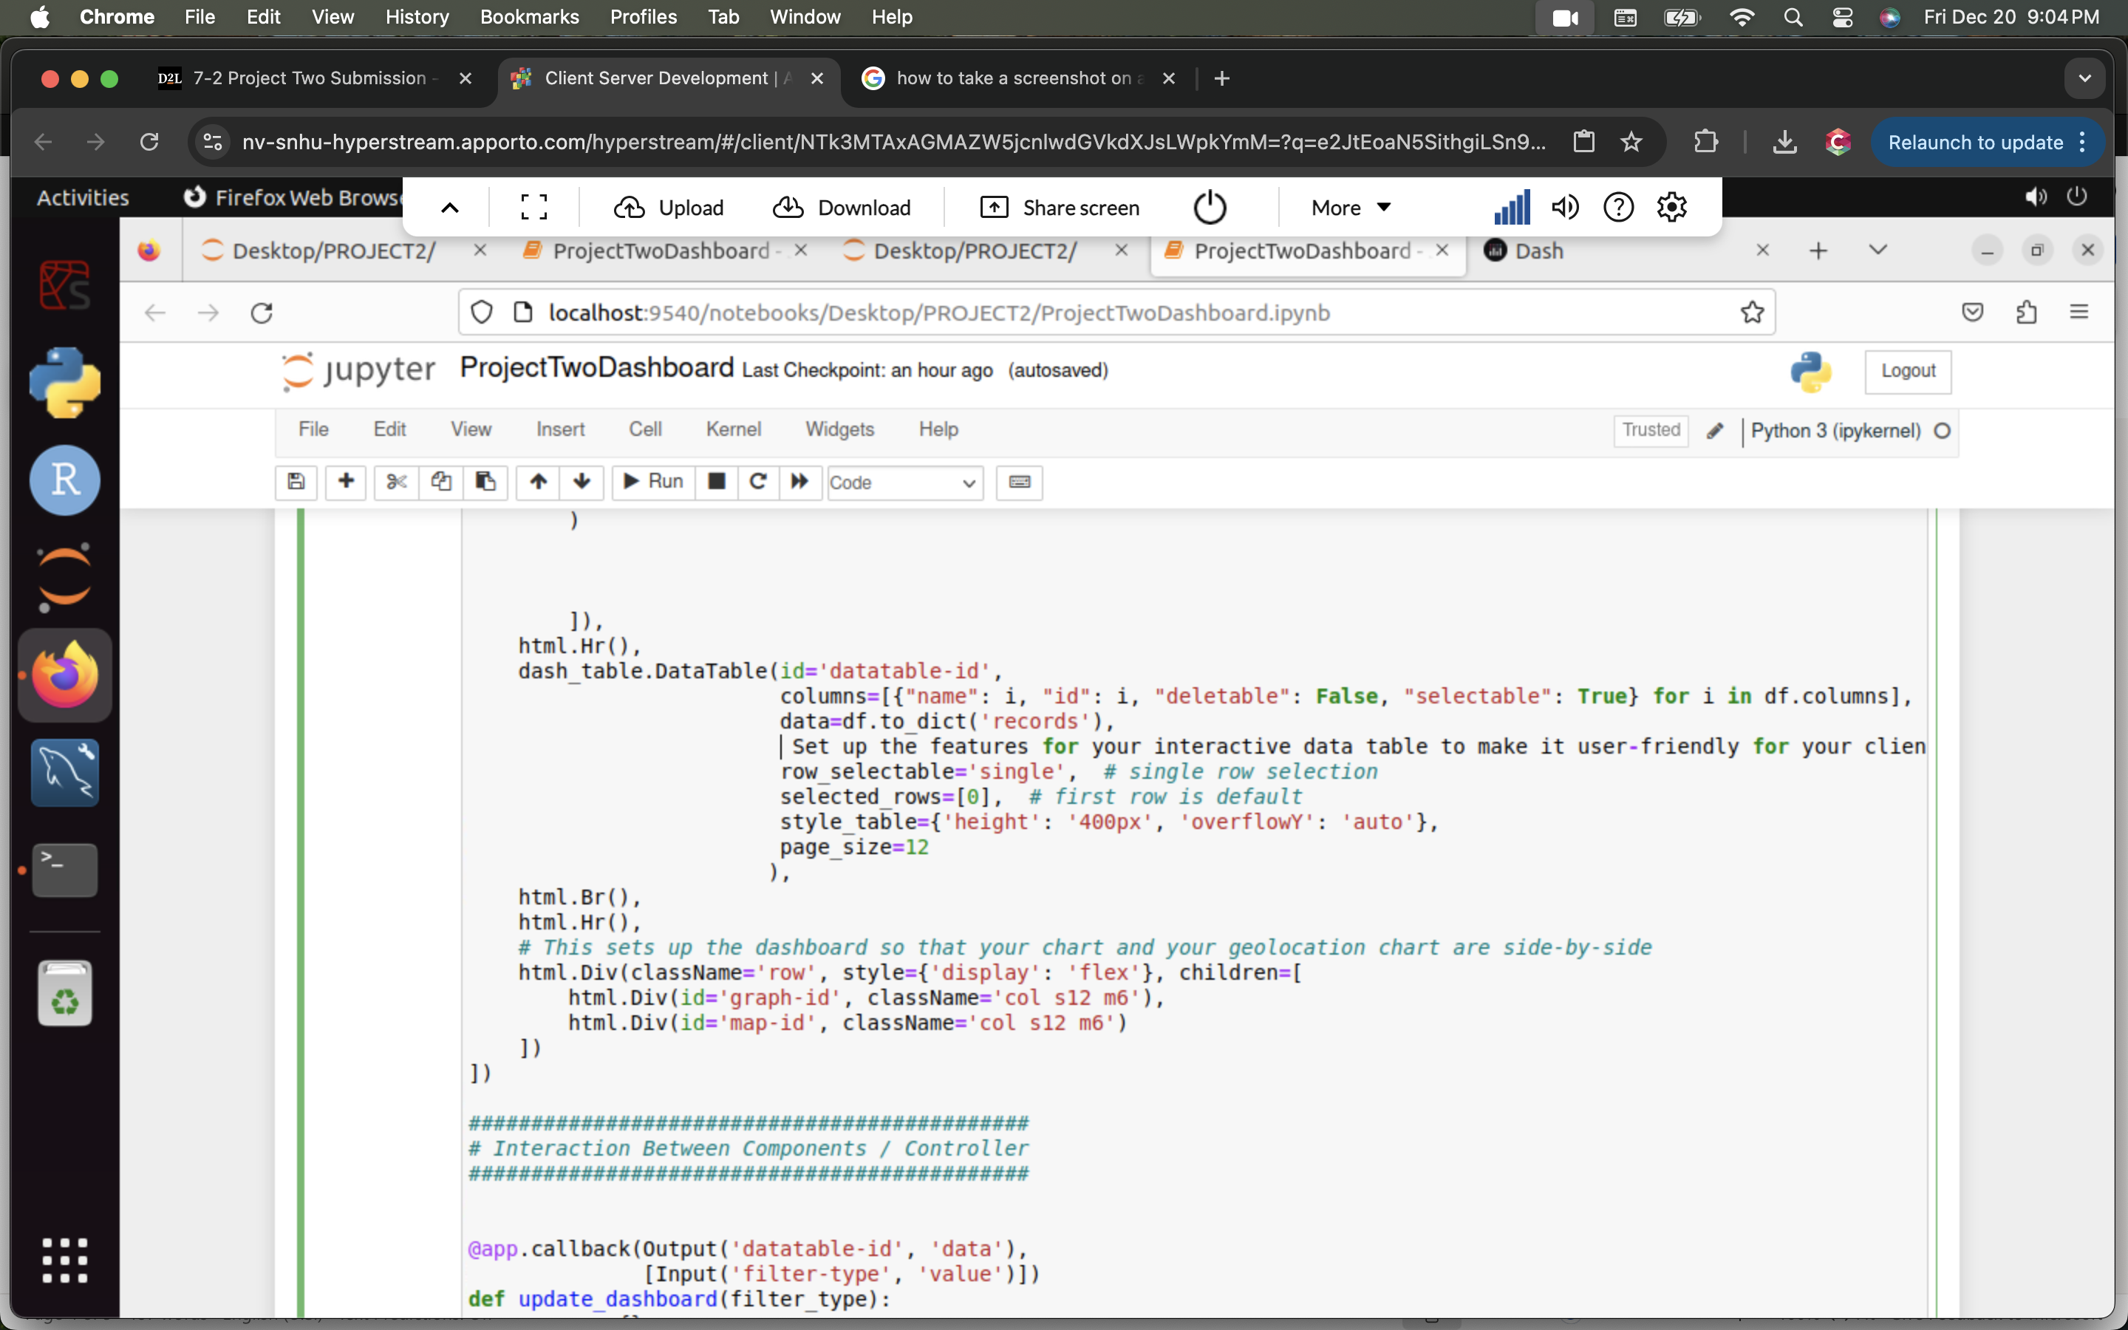This bit of code makes the data table more user friendly, it makes the first entry the entry selected. And allows 12 entries per page.

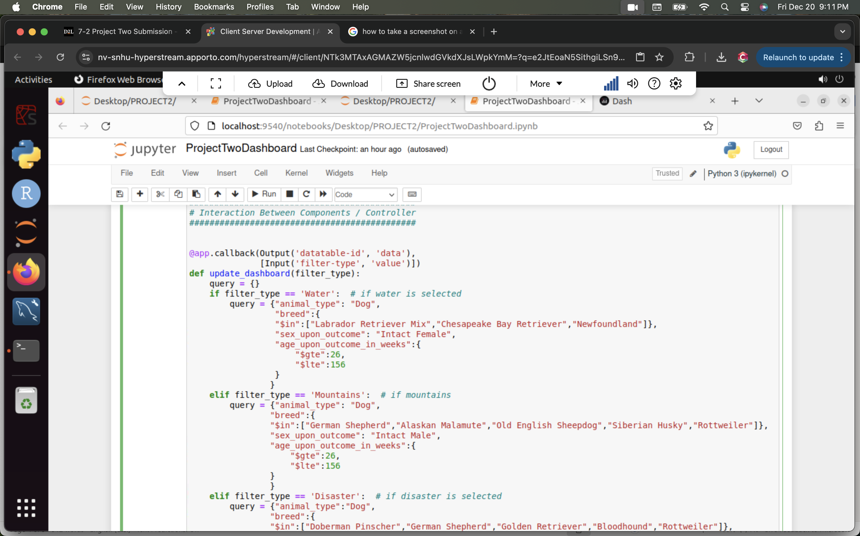

This is the callback method for the drop-down menu. If 'Water,' 'Mountains,' or 'Disaster' is selected, the application will query entries that match the respective parameters and return the results. If 'No filters' is selected, the query will return all entries as no parameters are applied.

In this bit of code is for the dash table which will display data from the query and will make each entry selectable.

This bit of code takes the data that is being displayed on the data table at a given time and converts it into a pie chart.

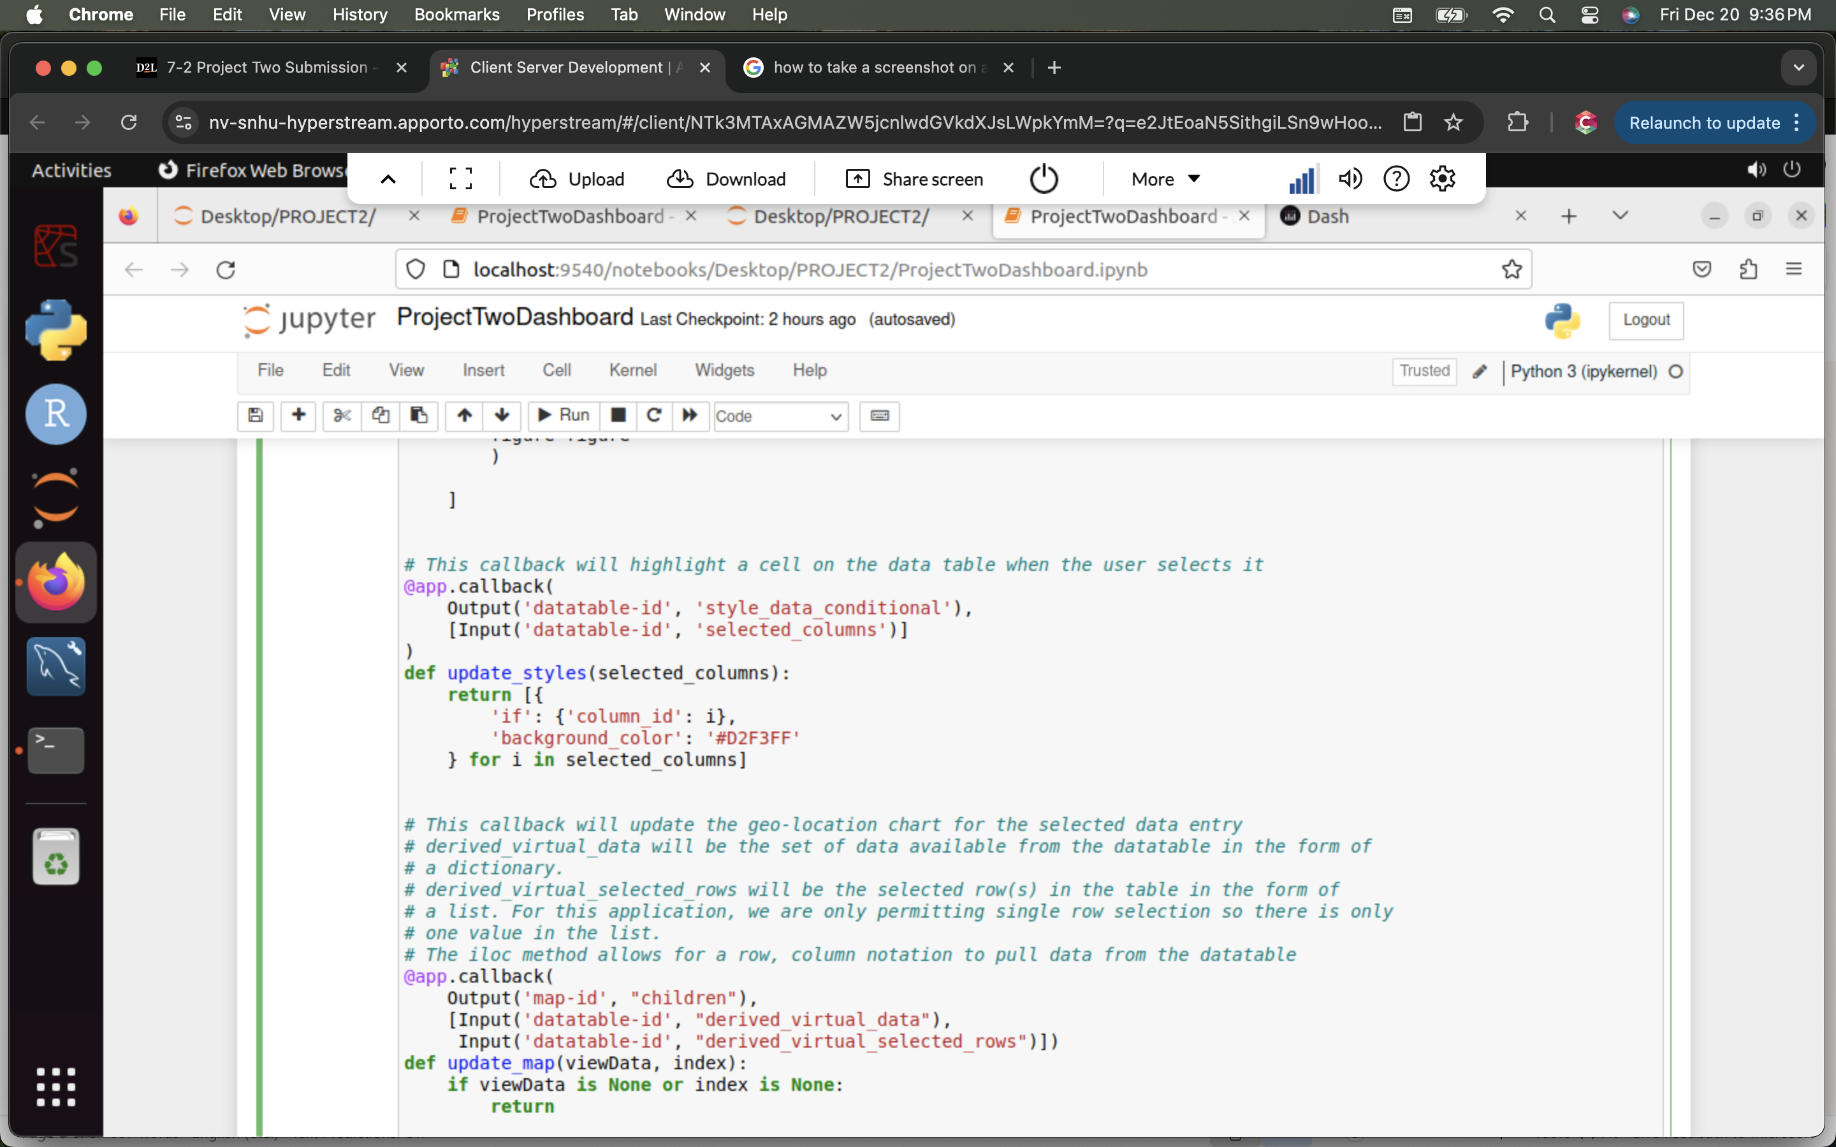

This bit of code allows the line of code selected by the user to be highlighted. This is a single selection.

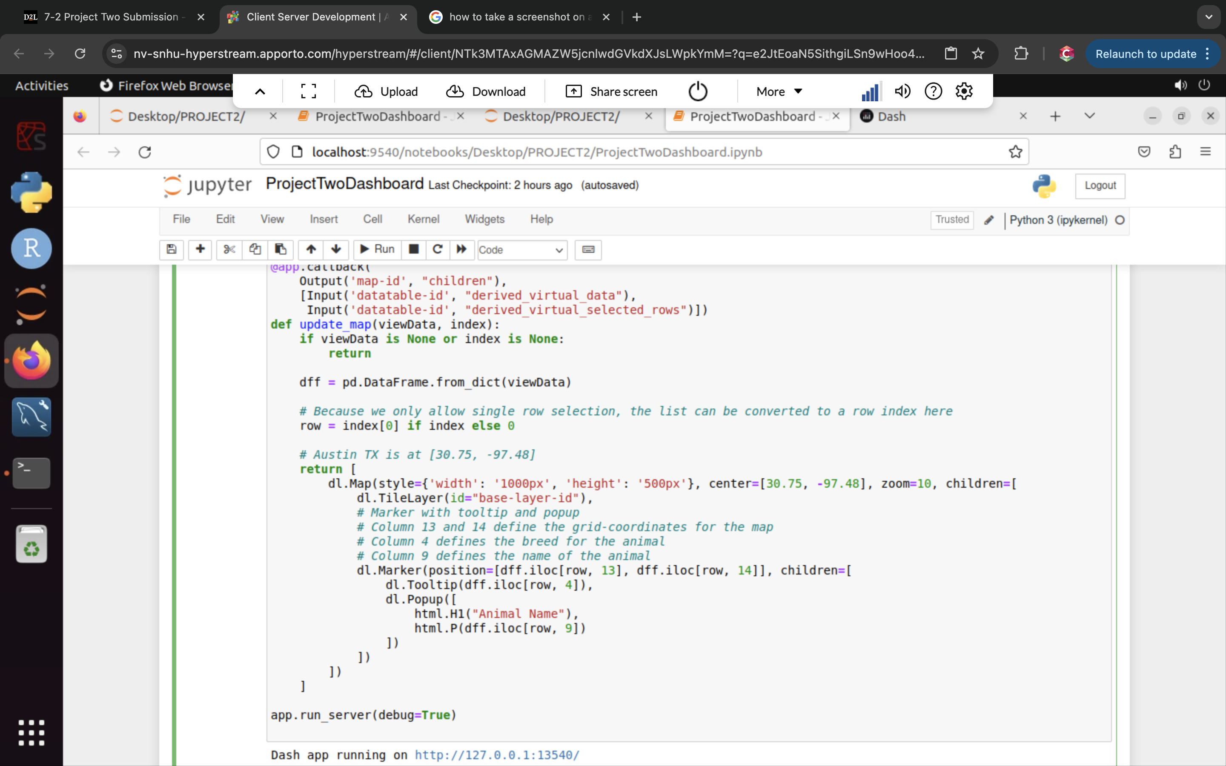

Finally, this bit of code creates a map which displays where the selected animal was found based on the queries coordinates.

### **Tests**

For ‘Water’ selection:

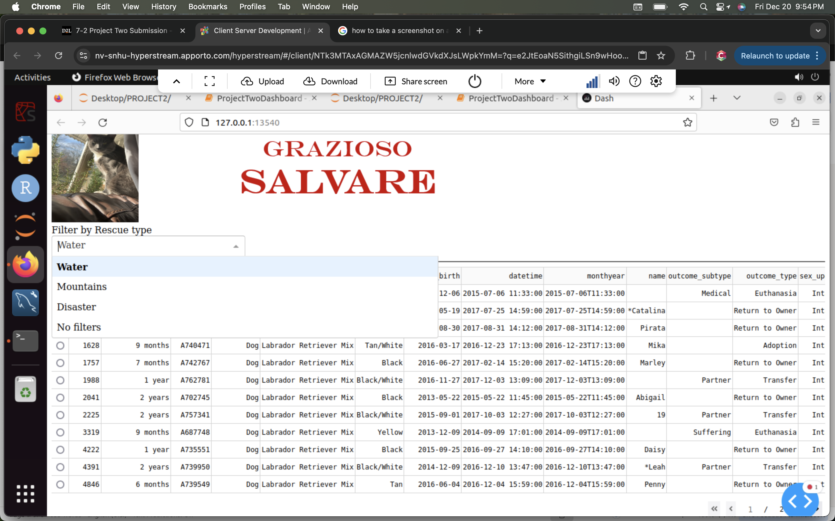

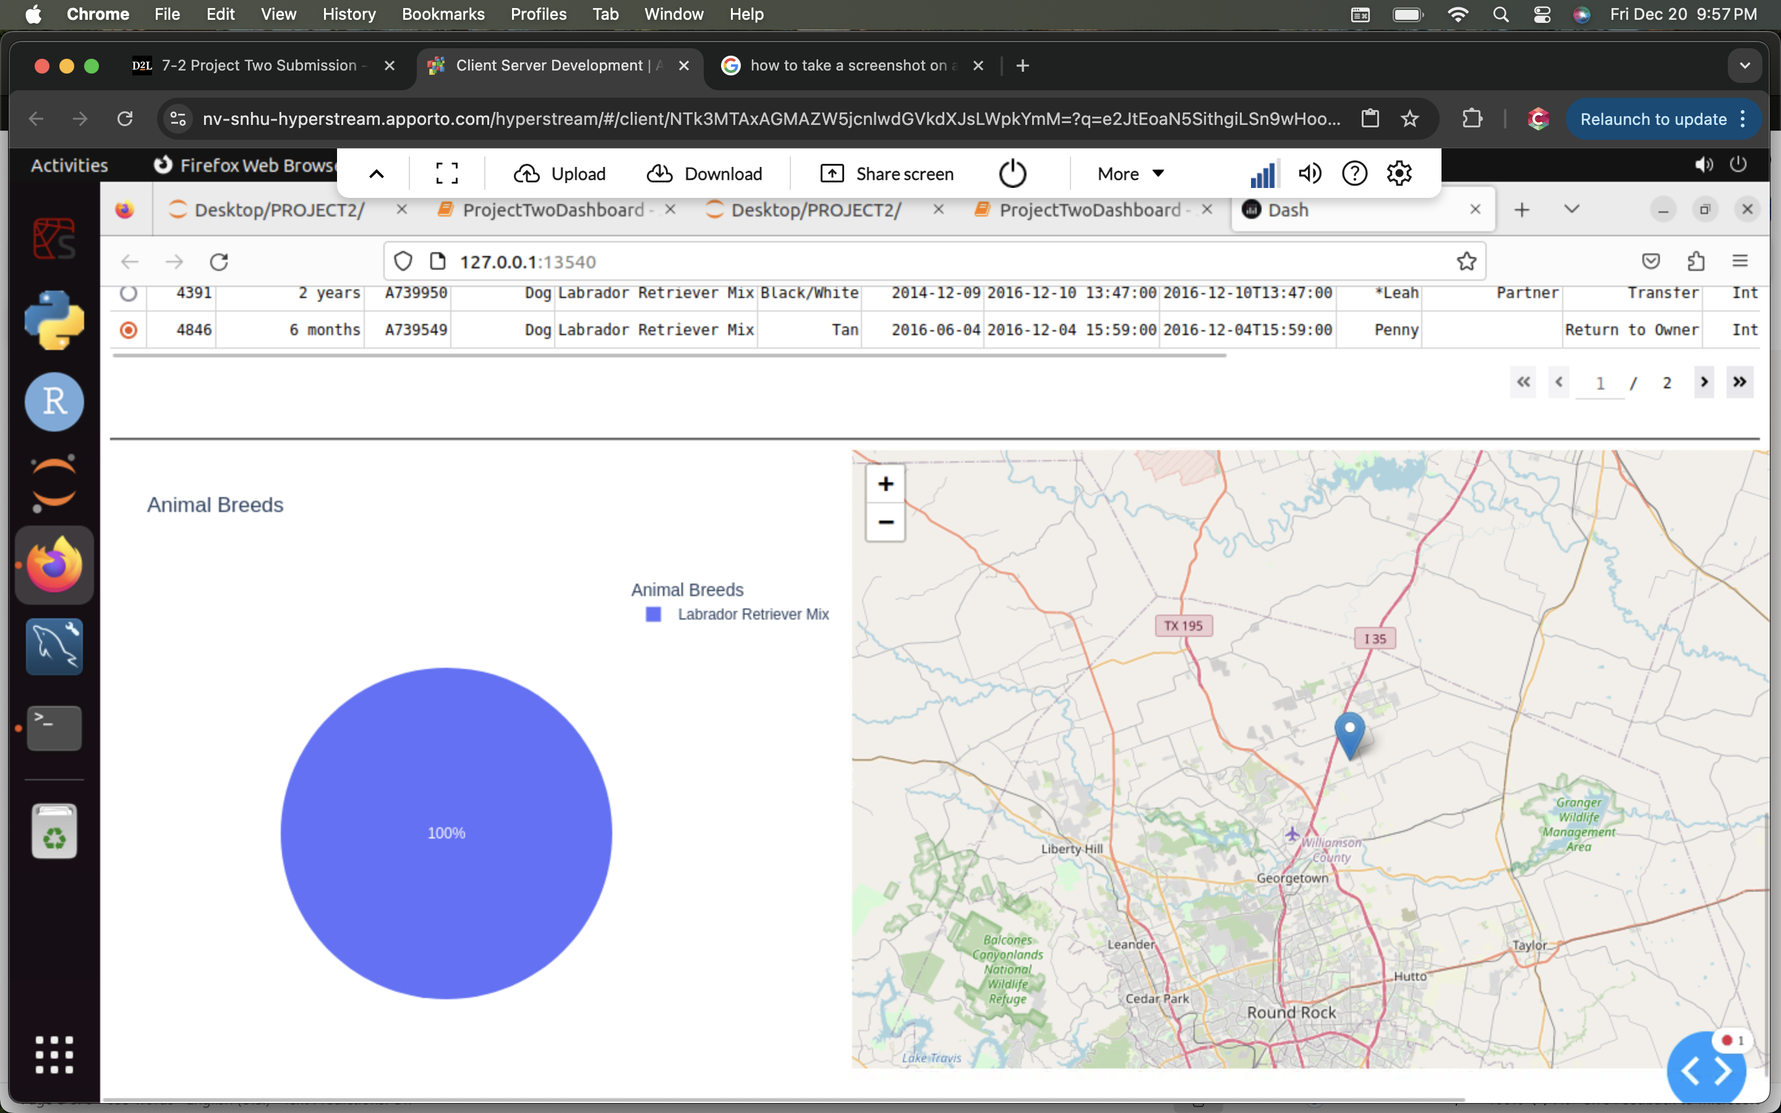

This tests for the “Water” rescue selection in then drop-down menu, it returns the entries that matched the given parameters and updated the pie-chart with the types of breeds.

For “Mountains” selection:

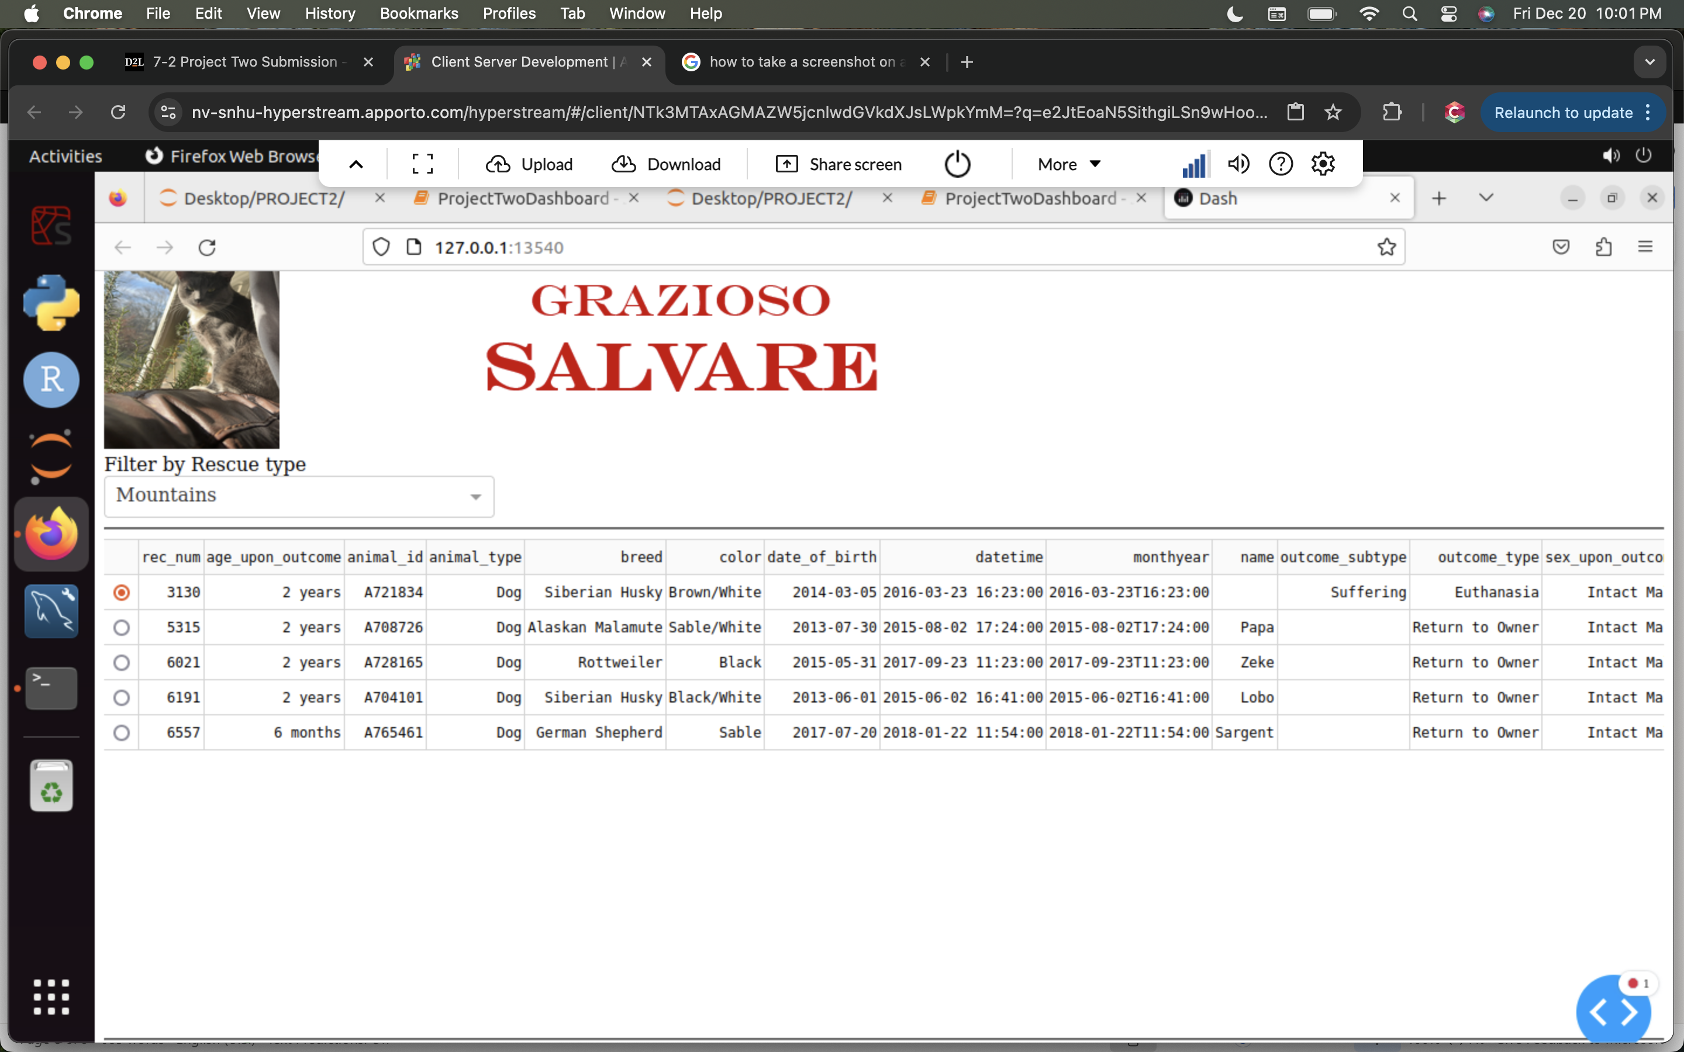

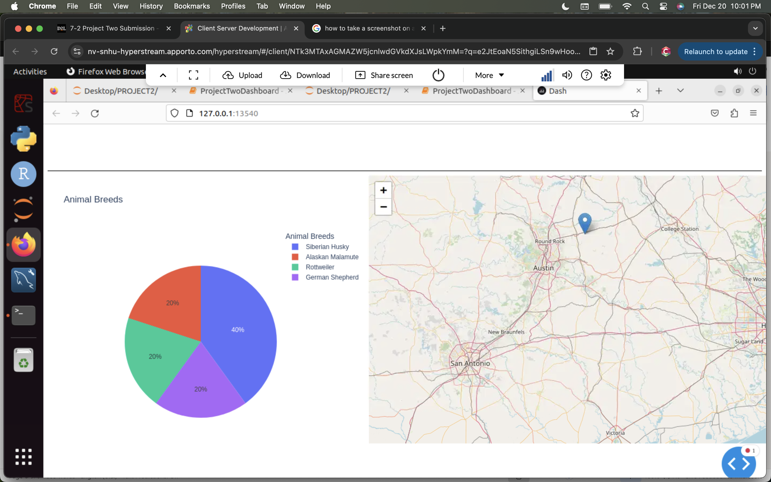

This tests for the “Mountains” rescue selection in then drop-down menu, it returns the entries that matched the given parameters and updated the pie-chart with the types of breeds.

For ‘Disaster’ Selection:

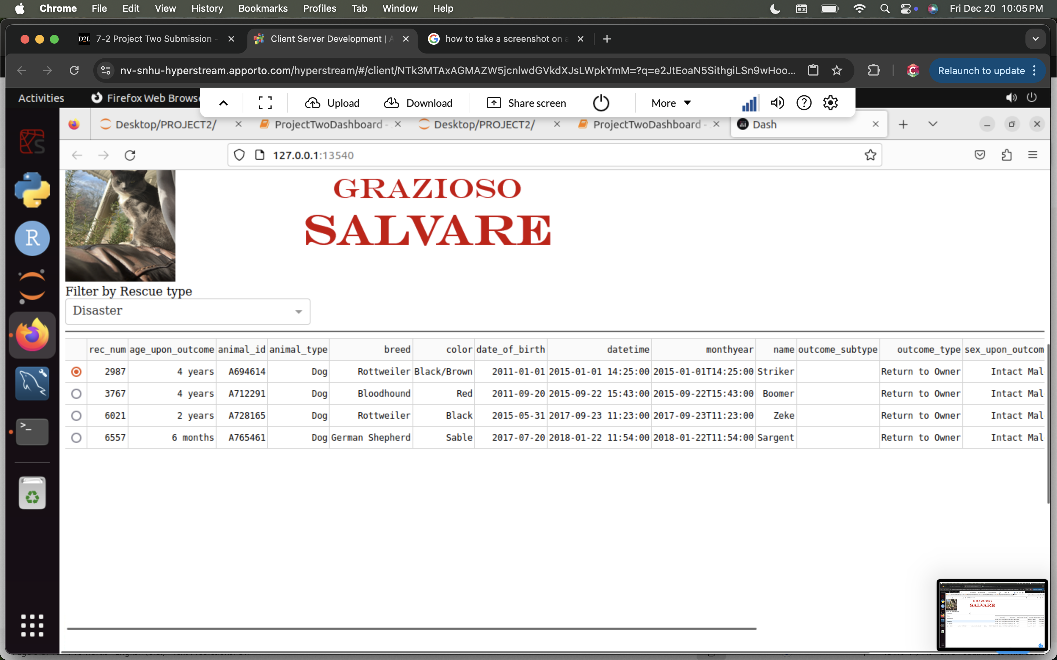

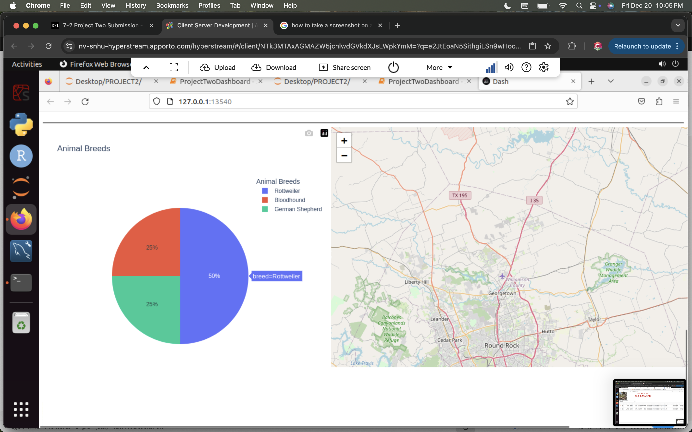

This tests for the “Disaster” rescue selection in then drop-down menu, it returns the entries that matched the given parameters and updated the pie-chart with the types of breeds.

For ‘No Filter’ Selection:

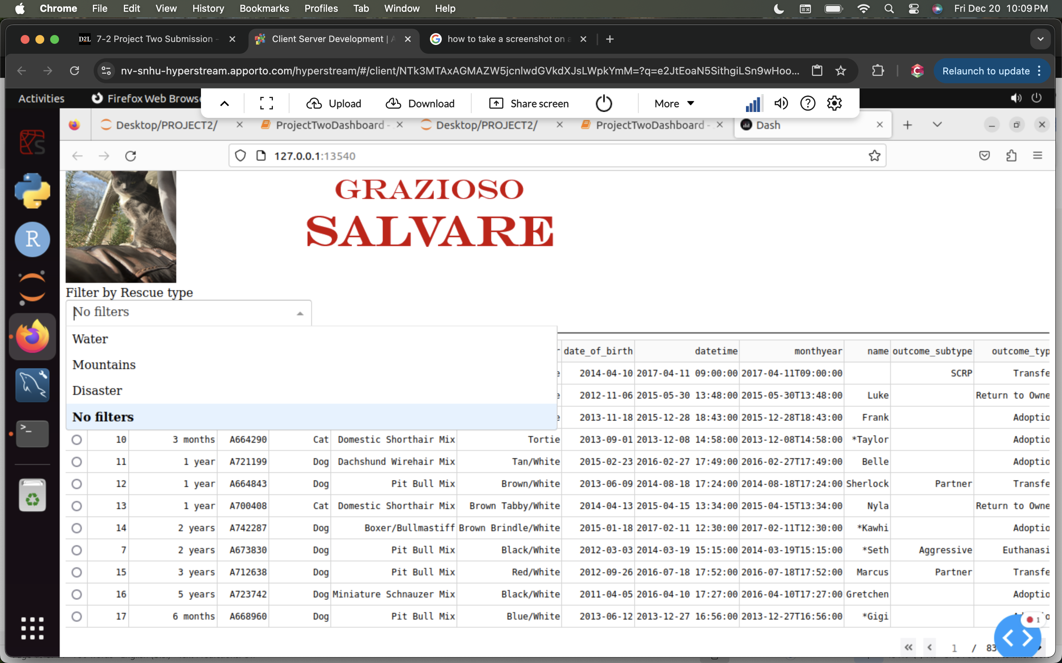

This tests for the “No filters” selection in the drop-down menu, it returns all the entries in the query since no parameters were given meaning all the data matches. The pie chart was also made to represent this data, and the map was updated upon selection.

## **Roadmap/Features (Optional)**

I think that for future features, including images in the database would be beneficial for the user of the Grazioso Salavare to visualize the sizes of the dogs. Showing images can help the user see the size of the dogs which may aid in the training program selection process. This could be executed by storing images into a folder and storing the file paths in the database. Upon selecting an entry an animal profile could pop up which has the most valuable information about the animal and contains a picture.   
  
**Contact**

Christina Jimenez

[christina.jimenez3@snhu.edu](mailto:christina.jimenez3@snhu.edu)